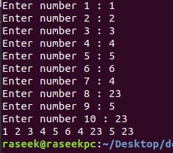q.1 init 10 nums in arr and display it

int main(){

int nums[10];

for (int i=0;i<10;i++){

printf("Enter number %d : ",i+1 );

scanf("%d",&nums[i]);

}

for (int i=0;i<10;i++){

printf("%d ",nums[i] );

}

}

// q.2 wap to readd n numbers frommm user and diplaay the numbers their sum andd average

int main(){

int n,sum=0;

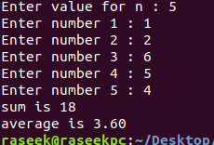 printf("Enter value for n : ");

scanf("%d",&n);

int arr[n];

for (int i=0;i<n;i++){

printf("Enter number %d : ",i+1 );

scanf("%d",&arr[i]);

sum += arr[i];

}

float avg = (float)sum/n;

printf("sum is %d\naverage is %.2f",sum,avg);

}

// q..3 ffind largest and smallest numss

int main(){

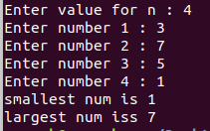 int n,largest,smallest;

printf("Enter value for n : ");

scanf("%d",&n);

int arr[n];

for (int i=0;i<n;i++){

printf("Enter number %d : ",i+1 );

scanf("%d",&arr[i]);

if (i==0){

largest = smallest = arr[0];

}

else{

if (largest < arr[i]){

largest = arr[i];

}

if (smallest > arr[i]){

smallest = arr[i];

}

}

}

printf("smallest num is %d\nlargest num iss %d\n",smallest,largest );

}

// q.4 wap to search item in array

int main(){

char arr[5][20] = {"random","pandas","os","sys","time"};

char query[20];

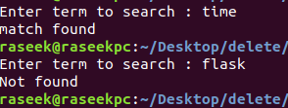 int found = 0;

printf("Enter term to search : ");

scanf("%s",query);

for (int i=0;i<5;i++){

if (strcmp(arr[i],query)==0){

printf("match found \n");

found = 1;

break;

}

}

if (!found){

printf("Not found\n");

}

}

// q.5 arrange item in ascending order

int main(){

char ch;

int n;

printf("Enter value for n : ");

scanf("%d",&n);

int arr[n];

for (int i=0;i<n;i++){

printf("Enter number %d : ",i+1 );

scanf("%d",&arr[i]);

}

printf("a. ascending order\nd. descending order\nChoose any : ");

scanf(" %c",&ch);

for (int i=0;i<n;i++){

for (int j=0;j<n-1;j++){

if (arr[j]>arr[j+1]){

// swap place

temp = arr[j];

arr[j] = arr[j+1];

arr[j+1] = temp;

}

}

}

if (ch=='a'){

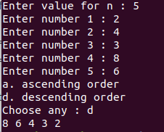 for (int i=0;i<n;i++){

printf("%d ",arr[i]);

}

}

else if (ch=='d'){

for (n--;n>=0;n--){

printf("%d ",arr[n] );

}

}

else{

printf("Invalid Choice\n");

}

printf("\n");

return 0;

}

// q.6 ask n nums and display only prime

int main(){

int n,count;

printf("Enter value for n : ");

scanf("%d",&n);

int arr[n];

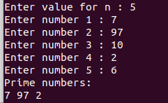 for (int i=0;i<n;i++){

printf("Enter number %d : ",i+1 );

scanf("%d",&arr[i]);

}

printf("Prime numbers:\n");

for (int i=0;i<n;i++){

count = 0;

for (int j=1;j<=arr[i];j++){

if (arr[i] % j == 0 ){

count++;

}

}

if (count ==2){

printf("%d ",arr[i]);

}

}

printf("\n");

return 0;

}

// q.7 count salaries between 40k and 60K among n employee

int main(){

int n,count=0;

printf("No of employees : ");

scanf("%d",&n);

int emp[n];

for (int i=0;i<n;i++){

printf("Salary for employee %d : ",i+1 );

scanf("%d",&emp[i]);

if (emp[i]>=40000 && emp[i]<=60000){

count++;

}

}

printf("No of employee with salary between 40K and 60K is %d\n",count );

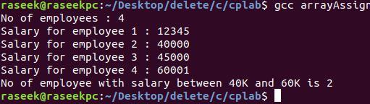}

// q.8 matrix addition

int main(){

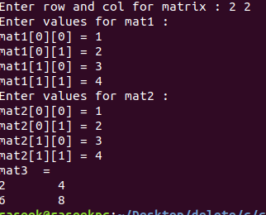 int row,col;

printf("Enter row and col for matrix : ");

scanf("%d %d",&row,&col);

int mat1[row][col],mat2[row][col],mat3[row][col];

printf("Enter values for mat1 : \n");

for (int i=0;i<row;i++){

for (int j=0;j<col;j++){

printf("mat1[%d][%d] = ",i,j);

scanf("%d",&mat1[i][j]);

}

}

printf("Enter values for mat2 : \n");

for (int i=0;i<row;i++){

for (int j=0;j<col;j++){

printf("mat1[%d][%d] = ",i,j);

scanf("%d",&mat2[i][j]);

mat3[i][j] = mat1[i][j] + mat2[i][j];

}

}

printf("mat3 = \n");

for (int i=0;i<row;i++){

for (int j=0;j<col;j++){

printf("%d\t",mat3[i][j]);

}

printf("\n");

}

}

// q.9 matrix multiplication

int main(){

int r1,c1,r2,c2,elem;

printf("print dimention of mat1 : ");

scanf("%d %d",&r1,&c1);

printf("print dimention of mat2 : ");

scanf("%d %d",&r2,&c2);

if (c1!=r2){

printf("matrix of order %d x %d and %d x %d cannot be multiplied\n",r1,c1,r2,c2 );

exit(0);

}

int mat1[r1][c1],mat2[r2][c2],mat3[r1][c2];

printf("Enter values for mat1 : \n");

for (int i=0;i<r1;i++){

for (int j=0;j<c1;j++){

printf("mat1[%d][%d] = ",i,j);

scanf("%d",&mat1[i][j]);

}

}

printf("Enter values for mat2 : \n");

for (int i=0;i<r2;i++){

for (int j=0;j<c2;j++){

printf("mat2[%d][%d] = ",i,j);

scanf("%d",&mat2[i][j]);

mat3[i][j] = mat1[i][j] + mat2[i][j];

}

}

// mat multiplication starts here

printf("mat3 = \n");

for (int i=0;i<r1;i++){

for (int j=0;j<c2;j++){

mat3[i][j] = 0;

for (int k=0;k<r2;k++){

mat3[i][j] += mat1[i][k] \* mat2[k][j];

}

}

}

for (int i=0;i<r1;i++){

for (int j=0;j<c2;j++){

printf("%d\t",mat3[i][j] );

}

printf("\n");

}

}

// q.10 transpose matrix

int main(){

int row=2,col=2,temp;

int mat[row][col];

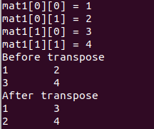 for (int i=0;i<row;i++){

for (int j=0;j<col;j++){

printf("mat1[%d][%d] = ",i,j);

scanf("%d",&mat[i][j]);

}

}

printf("Before transpose\n");

for (int i=0;i<row;i++){

for (int j=0;j<col;j++){

printf("%d\t",mat[i][j]);

}

printf("\n");

}

for (int i=0;i<row;i++){

for (int j=0;j<col;j++){

if (i>j){

temp = mat[i][j];

mat[i][j] = mat[j][i];

mat[j][i] = temp;

}

}

}

printf("After transpose\n");

for (int i=0;i<row;i++){

for (int j=0;j<col;j++){

printf("%d\t",mat[i][j]);

}

printf("\n");

}

}

// q.11 sum of diagonla element

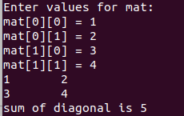int main(){

int row=2,sum=0; // give me squre matrix

int mat[row][row];

printf("Enter values for mat: \n");

for (int i=0;i<row;i++){

for (int j=0;j<row;j++){

printf("mat[%d][%d] = ",i,j);

scanf("%d",&mat[i][j]);

if (i==j){

sum += mat[i][j];

}

}

}

for (int i=0;i<row;i++){

for (int j=0;j<row;j++){

printf("%d\t",mat[i][j]);

}

printf("\n");

}

printf("sum of diagonal is %d\n",sum );

}